Project Executable Files

Date | 2 July 2026
Team ID | xxxxxx
Project Name | Smart Lender
Maximum Marks | 3 Marks

Project Executable Files

Step 1: Submission Checklist

S.No | Item to Submit | Submitted (Yes /  No / NA)
1 | Complete source code (all files and folders) | Yes
2 | README / Setup Guide (instructions to run the project) | Yes
3 | requirements.txt / package.json / dependency file | Yes
4 | Database schema / seed files (if applicable) | NA
5 | Environment configuration file (.env.example or similar) | NA
6 | Deployed application URL (if hosted) | No (Local Deployment)
7 | APK / Executable binary (if applicable for mobile/desktop apps) | NA
8 | Dockerfile / Containerization config (if applicable) | NA
9 | Test files and test results | Yes
10 | Demo video or walkthrough (if required) | Yes

(Step 2: File / Folder Structure
Provide an overview of your project's file and folder structure below:

Smart_Lender/
│
├── Dataset/
│ └── loan_prediction.csv
│
├── Training/
│ └── Smart Lender Using ML.ipynb
│
├── Flask/
│ ├── app.py
│ ├── requirements.txt
│ ├── xgb_model.pkl
│ ├── scale1.pkl
│ │
│ ├── Templates/
│ │ ├── index.html
│ │ └── result.html
│ │
│ └── Static/
│ ├── style.css
│ └── background.jpeg
│
├── Project_Screenshot_Images.pdf
│
└─── README.md

Step 3: Deployment / Access Details

Field | Details
Hosted / Deployed URL | Not Hosted (Runs Only Local Flask Application)
Login Credentials  (Demo) | Not Applicable (No Login Required)
Platform / Hosting  Provider | Local Flask Development Server
Repository Link | https://github.com/sivasankarpilli/smart-lender-loanprediction
Demo Video Link | https://drive.google.com/file/d/1JgW4P2kqRXlz28WcJpJED8xurcGbGdDv/view

Step 4: Run Instructions

Pre-requisites:

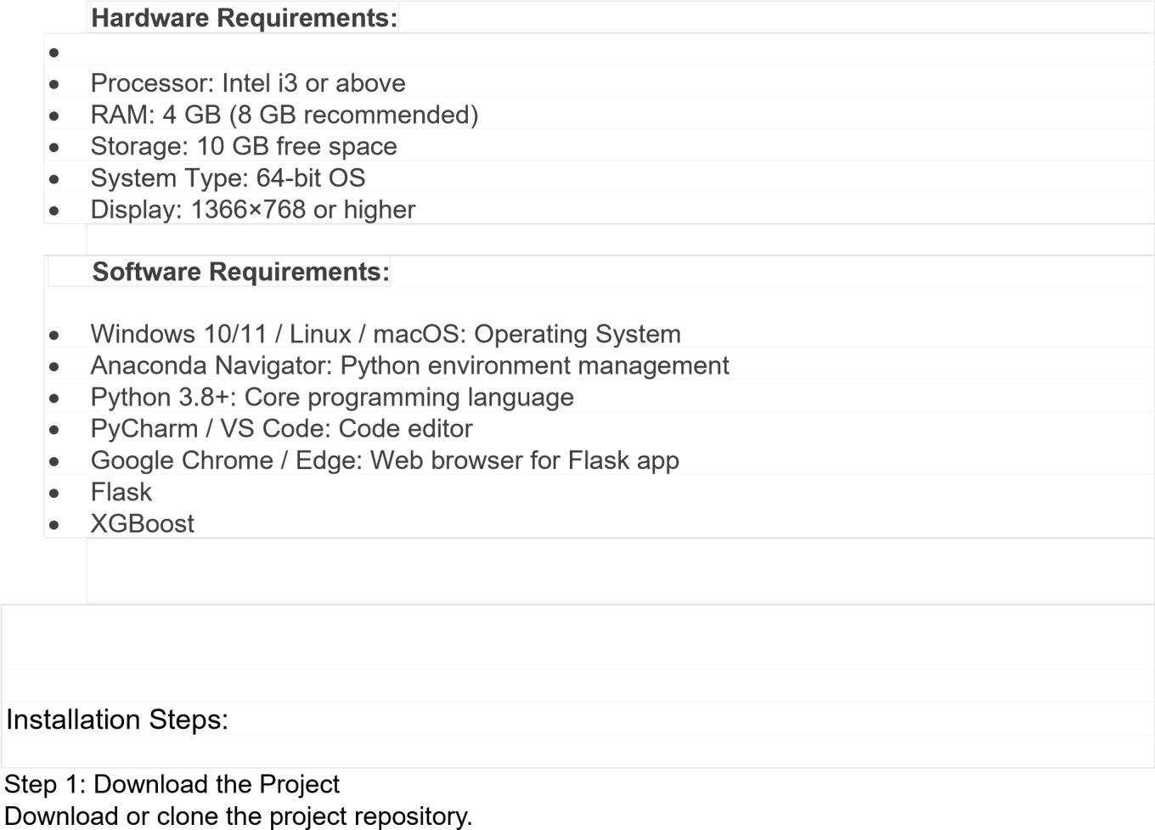 git clone <repository-url> cd Smart-Lender
Alternatively, extract the provided ZIP file into a folder.
Step 2: Create a Virtual Environment
Create a virtual environment to isolate project dependencies.
Windows:
python -m venv venv venv\Scripts\activate Linux/macOS: python3 -m venv venv source
venv/bin/activate

Step 3: Install Required Packages Install all required Python libraries.
pip install flask pip
install pandas pip install numpy pip install scikit-learn pip install xgboost pip install joblib pip install matplotlib pip install jupyter
Or, if a requirements.txt file is available: pip install
-r requirements.txt

Step 5: Run the Flask Application
Navigate to the Flask directory and start the server. cd Flask python app.py
The application server will start successfully.
Example output:
* Running on http://127.0.0.1:5000/

Step 6: Open the Application Open any web browser and visit: http://127.0.0.1:5000
The Smart Lender web application homepage will appear.

Step 7: Test Loan Prediction
- Enter applicant details in the form.
- Click the Predict button.
- The system processes the data using the trained XGBoost model.
- The prediction result (Loan Approved/Rejected) is displayed on the result page.

Step 5: Known Issues / Limitations

S.No | Known Issue / Limitation | Workaround / Status
1 | Model prediction depends on training dataset quality | Can be improved by training with a larger and more diverse  dataset
2 | Application runs locally by default | Can be deployed on IBM Cloud, Render, or another cloud platform
3 | No User Authentication | Can be release in future version.

